Mission Architecture for Result-Centric Hyperspectral Downlink in Low-Earth-Orbit Constellations

Keon-Woo Koo
Dept. of Computer Science and Engineering, Sungkyunkwan University, Suwon 16419, Republic of Korea
Mohammed H Hamza
Dept. of Aerospace Engineering, Korea Advanced Institute of Science and Technology, Daejeon 31414, Republic of Korea
Dinaol Gadisa
Dept. of Aerospace Engineering, Korea Advanced Institute of Science and Technology, Daejeon 31414, Republic of Korea
Myungchul Choi
Robotics, University of Science and Technology, Gwangju 61012, Republic of Korea
Jaehwan Park
Space Robotics and Deep Learning Institute, KL.Space Co., Ltd., Jinju 52828, Republic of Korea
Hyo-Choong Bang
Dept. of Aerospace Engineering, Korea Advanced Institute of Science and Technology, Daejeon 31414, Republic of Korea
Jaekwang Kim
Dept. of Computer Science and Engineering, Sungkyunkwan University, Suwon 16419, Republic of Korea
Dong-Ho Yun
Robotics, University of Science and Technology, Gwangju 61012, Republic of Korea

Abstract :
Earth-observation constellations are increasingly constrained by intermittent downlink opportunities rather than sensing capacity, particularly when hyperspectral payloads generate large data cubes. Existing workflows typically downlink raw imagery before analysis, delaying actionable delivery and increasing contact demand. This study proposes a result-centric mission architecture that performs onboard segmentation, extracts regions of interest, packages a compact semantic alert, retains raw data locally, and schedules later evidence retrieval when needed. Mamba-OpticSatNet is implemented in two configurations: Full, an accuracy-oriented model combining parallel Transformer and selective state-space branches through adaptive gated fusion; and Lite, a deployment-oriented model that reduces token-processing cost and complexity. On a four-class derivative of OHID-1, Full achieved an mIoU of 0.908, while Lite achieved 0.877 with 0.288 million parameters and 0.066 giga multiply–accumulate operations (GMACs). Lite processed an evaluated cube in 1.698 s on Jetson AGX Orin at 25 W, consuming 42.44 J per inference. In an STK scenario with 20 satellites at 450 km and 76° inclination, average ground-station access was 302 s. At an illustrative 1 Mbit/s S-band application-layer throughput, a 1.64 GB cube required 13,120 s and 44 mean-duration contacts, whereas a 100 kB semantic alert required 0.8 s and one contact, reducing initial alert-downlink volume by 99.9939%. These results support an alert-first, evidence-later concept of operations, while absolute mission latency remains dependent on contact chronology, scheduling, protocol overhead, and link-budget conditions.

Keyword : Earth Observation; Satellite Constellation; Hyperspectral Imaging; Onboard Processing; Semantic Downlink; Mission Latency; Edge Computing.

1. Introduction:
1.1 Constellation Earth Observation and Downlink Challenges
Small satellites and CubeSat-class platforms have lowered the cost and schedule barriers associated with Earth-observation missions. Standardized buses, commercial components, and repeatable manufacturing make it practical to distribute sensing capability across multiple spacecraft rather than concentrating it in a single large observatory. Constellation geometry can then be selected to improve revisit time, temporal sampling, resilience, and service continuity [1], [2]. The architectural advantage is particularly strong for transient phenomena such as floods, wildfires, coastal contamination, algal blooms, and rapidly changing land-surface conditions, for which the value of an observation decreases as the delay between acquisition and actionable delivery increases.
The same architecture that increases observation opportunity also multiplies payload data generation. A hyperspectral imager records a spectrum at every ground-projected pixel, so a single acquisition is a three-dimensional cube with two spatial axes and one spectral axis. The number of bytes grows with image extent, spectral-band count, radiometric depth, calibration products, and ancillary information. In a constellation, several spacecraft may produce these cubes concurrently while each satellite has only intermittent contact with a limited set of ground stations. The operational bottleneck therefore shifts from the ability to collect imagery to the ability to schedule, transmit, receive, and process it before it loses decision value.
Ground-station scheduling studies treat visibility, antenna conflicts, priorities, data backlog, and resource allocation as coupled optimization variables [3]. Adding stations, higher-rate radios, optical links, or commercial ground-network services can increase capacity, but these measures also add cost, licensing, pointing, weather, and integration constraints. For many small-satellite missions, the more scalable first question is not only how to send more bits, but which information must be sent first. Orbital edge-computing research has accordingly reframed a satellite constellation as a distributed computer system whose sensing, processing, storage, and communication functions should be co-designed [4], [5].
This paper adopts that system view. The proposed mission does not treat segmentation as an isolated image-analysis application. Instead, segmentation is one element of an end-to-end information architecture that converts raw hyperspectral measurements into prioritized mission products. The primary operational product is a compact semantic alert containing the location, extent, class, confidence, time, quality flags, and provenance of detected regions of interest (ROIs). Raw cubes and richer image products remain onboard for later evidence retrieval, calibration analysis, or model reprocessing. Architecture therefore creates a fast semantic path and a slower evidence path rather than discarding the scientific record after inference.

1.2 Onboard Processing for Hyperspectral Mission
Autonomous science-event detection has a long flight heritage. Work on Earth Observing-1 demonstrated that onboard classifiers could identify science events and alter the downstream observation workflow before ground analysis [6]. More recently, Phi-Sat-1 demonstrated deep neural-network inference for Earth-observation cloud filtering in orbit, showing that compact commercial accelerators can support useful payload decisions when integrated with appropriate mission safeguards [7]. These demonstrations established the operational principle that not every acquired pixel needs equal downlink priority.
Hyperspectral missions impose a harder version of the same problem because spectral richness creates both scientific value and large data volume. Robust, reconfigurable onboard-processing architectures have been developed for hyperspectral small satellites, with attention to data handling, fault recovery, and flexible processing chains [8]. HYPSO-1 studies have also used onboard classification to guide image capture and downlink selection, directly linking inference outputs to operations [9]. A recent survey of onboard hyperspectral processing identifies model size, computational throughput, power, radiation effects, limited labels, domain shift, and verification as persistent barriers to operational deployment [10].
At the algorithm level, hyperspectral segmentation work has compared one-dimensional spectral networks, two-dimensional spatial-spectral networks, and transformer variants with deployment in mind [11]. In-orbit deployment of a compact 1D-CNN further demonstrated that segmentation can support satellite operations when the model and data path are designed together [12]. Other studies have moved processing closer to raw sensor data to avoid expensive ground-like preprocessing, including onboard use of raw multispectral imagery [13], contaminant monitoring for future PhiSat-2 operations [14], [15], and thermal-hotspot segmentation using raw multispectral measurements [16].
Recent applications also emphasize low-demand mission products. Machine-learning approaches have been proposed for global flood mapping on low-cost satellites [17], lightweight cloud masking in hyperspectral imagery [18], and onboard change detection for disaster monitoring [19]. ROI-based hyperspectral compression reduces data volume while retaining selected image regions [15], but a semantic alert goes further: it sends a task-specific interpretation that cannot reconstruct the original radiance cube. The benefit is a much smaller payload; the cost is greater dependence on model validity, calibration, geolocation, and mission policy.
Hardware feasibility must therefore be separated from flight qualification. Hybrid and reconfigurable onboard computing can provide high throughput, but radiation, thermal design, power transients, software faults, and reset behavior remain system concerns [20], [21]. Proton testing of Jetson-class devices and in-orbit evaluations of heterogeneous commercial-off-the-shelf (COTS) architectures show both their promise and their vulnerability [22], [23]. A laboratory result on a Jetson module is evidence of computational feasibility; it is not, by itself, evidence that the module is qualified for an operational spacecraft.
The literature therefore contains strong results on onboard event detection, hyperspectral inference, compression, edge hardware, and ground scheduling, but these strands are often evaluated separately. The specific gap addressed here is an end-to-end mission architecture that links a hyperspectral semantic product, an onboard segmentation model, embedded execution, a constellation contact scenario, and a transparent distinction between transmission-time reduction and absolute mission-latency reduction.

1.3 Problem Definition
Consider an Earth-observation mission in which each acquisition produces a raw hyperspectral product $P_{0}$. An onboard processor may convert $P_{0}$ into one of three lower-volume mission products: an ROI-cropped cube $P_{1}$, a segmentation raster $P_{2}$, or a semantic alert $P_{3}$ containing only decision-relevant metadata, such as class, location, area, confidence, and acquisition time. For an onboard model $m∈M$ and product tier $p∈P=\{0,1,2,3\}$, the selected mission product is expressed as

$P_{p}=g_{m,p}\left(P_{0}\right),$ (1)

Here $g_{m,0}$ is the identity mapping for conventional raw-cube downlink, and $g_{m,p}$, $p∈P=\{0,1,2,3\}$, denotes the onboard transformation used to generate the corresponding reduced product.
The mission-design objective is to reduce the amount of data transmitted to the ground and the time required to deliver actionable information, while maintaining sufficient task performance and remaining within onboard resource limits. Because data volume, latency, energy, and semantic risk have different physical units, the trade is expressed using a normalized mission-level cost function:

$J\left(m,p\right)=w_{D}\frac{D_{p}}{D_{0}}+w_{L}\frac{L_{post}\left(m,p\right)}{L_{req}}+w_{E}\frac{E_{proc}(m,p)}{E_{avail}}+w_{R}{\tilde{R}}_{sem}\left(m,p\right).$ (2)

Here $D_{p}$ is the size of the selected product, $D_{0}$ is the raw-cube size, $L_{post}(m,p)$ is the post-acquisition latency required to deliver the selected product, $L_{req}$ is the maximum acceptable mission latency, $E_{proc}\left(m,p\right)$ is the onboard processing energy required to generate the product, and $E_{avail}$ is the energy allocated to processing one observation. The normalized semantic-risk term ${\tilde{R}}_{sem}\left(m,p\right)∈[0,1]$ represents the operational risk associated with replacing the original measurement with a task-specific product, including missed events, false alarms, geolocation errors, model drift, and loss of information required for subsequent scientific analysis.
The mission-dependent weights satisfy.

$w_{D}, w_{L},w_{E},w_{R}≥0, w_{D}+ w_{L}+w_{E}+w_{R}=1.$ (3)

Equation (2) is introduced as a conceptual mission-trade formulation rather than as an optimization problem that is numerically solved in this study. The candidate operating point must nevertheless satisfy the principal onboard and mission constraints:

$\begin{matrix}Q\left(m,p\right) & ≥Q_{req}, \\ T_{proc}\left(m,p\right) & ≤T_{proc,max}, \\ E_{proc}(m,p) & ≤E_{avail}, \\ M_{peak}(m,p) & ≤M_{avail}, \\ S_{buf}\left(m,p\right) & ≤S_{avail}, \\ R_{rel}\left(m,p\right) & ≥R_{req}.\end{matrix}$ (4)

Here $Q\left(m,p\right)$ denotes the mission-relevant product quality or task performance, $T_{proc}\left(m,p\right)$ is the onboard processing time, $M_{peak}(m,p)$ is peak memory demand, $S_{buf}\left(m,p\right)$ is the required storage-buffer capacity, and $R_{rel}\left(m,p\right)$ is the processing and delivery reliability. The corresponding threshold and resource-limit terms define the minimum performance and reliability requirements, and the maximum allowable processing time, energy, memory, and storage demands.
For a representative ground contact with duration ${\overline{T}}_{c}$, effective application-layer downlink throughout $R_{eff}$, and product size $D_{p}$, the approximate number of contacts required for delivery is

$N_{cont}\left(p\right)=​\left[\frac{B_{p}}{R_{eff}{\overline{T}}_{c}}\right].$ (5)

Accordingly, the central hypothesis evaluated in this study is that, under the representative contact conditions, the semantic-alert product can be delivered within one contact, whereas the raw hyperspectral product requires multiple contacts.

$B_{3}≤R_{eff}{\overline{T}}_{c}, { B}_{0 }>R_{eff}{\overline{T}}_{c}.$ (6)

For a product that can be delivered within a single usable contact, the post-acquisition latency is approximated as

$L_{post}\left(m,p\right)≈T_{proc}\left(m,p\right)+T_{wait}(m,p)+\frac{B_{p}}{R_{eff}}+T_{ground}(p).$ (7)

where $T_{wait}(p)$ is the time between product generation and the beginning of a usable communication window, and $T_{ground}(p)$ is the ground-side reception, decoding, and processing time. Equation (7) is a single-contact approximation. Products that require multiple contacts additionally experience delays caused by contact spacing, scheduling conflicts, and possible retransmission,

This formulation directly supports the four main contributions of the study.
- First, it expresses the hyperspectral downlink bottleneck as a mismatch between onboard data generation and available ground-contact capacity.
- Second, it defines result-centric downlink as a change in the transmitted product from the full measurement $P_{0}$ to a smaller decision-oriented product $P_{3}$.
- Third, it links the segmentation performance and embedded execution cost of Mamba-OpticSatNet to mission-level resource constraints.
- Finally, it defines the quantities required to evaluate transmitted volume, contact demand, and post-acquisition latency through mission-scenario analysis. The present study does not solve the complete optimization problem in Eq. (2); instead, it evaluates the combination of Mamba-OpticSatNet(Lite) and the $P_{3}$ semantic-alert product as one candidate operating point.

2. Hyperspectral Downlink Framework
2.1 Hyperspectral Data and Semantic Compression
A calibrated hyperspectral acquisition is represented as $X ∈ R^{H×W×B}$, where H and W are the spatial dimensions and B is the number of spectral bands. For q-bits samples, the nominal uncompressed radiometric data volume is

$D_{rad} = \left[\frac{HWBq}{8}\right].$ (8)

Where $D_{rad}$is expressed in bytes. Equation (8) represents the radiometric sample data only and does not include calibration metadata, geolocation information, quality flags, file headers, or formatting overhead.
The complete raw or calibrated product P₀ is therefore represented as

$D_{0} = D_{rad} + D_{anc}$ (9)

where $D_{anc}$ denotes ancillary information and product-format overhead, including calibration parameters, geolocation data, quality flags, timestamps, and file headers. Link-layer and physical-layer communication overhead are not included in $D_{anc}$; they are instead reflected in the effective application-layer throughout $R_{eff}$.
Conventional hyperspectral compression reduces redundancy while preserving a decodable cube. In contrast, the proposed framework performs task-oriented semantic reduction by converting P₀ into an ROI crop P₁, a segmentation raster P₂, or a semantic alert P₃. The framework is designed so that P₁ and P₂ reduce the transmitted volume relative to the raw product, while P₃ provides a substantially smaller decision-oriented representation:

${E\left[D_{1}\right]<D}_{0}, {E\left[D_{2}\right]<D}_{0}, {E\left[D_{3}\right]≪D}_{0}$ (10)

No universal ordering between $D_{1}$ and $D_{2}$ is assumed because their relative sizes depend on the number and spatial extent of the detected ROIs, the raster representation, the number of classes, the numerical precision of stored probabilities, and the selected encoding or compression method.

The characteristics and intended operational roles of the four mission-product tiers are summarized in Table 1.

Table 1. Mission-product hierarchy for result-centric downlink.
Tier | Product | Retained information | Primary use
P₀ | Raw/calibrated cube | Full spectral, spatial, and calibration information | Reprocessing, archive, and model audit
P₁ | ROI-cropped cube | Selected pixels and local context | Analyst confirmation
P₂ | Segmentation raster | Per-pixel labels or probabilities | Rapid mapping
P₃ | Semantic alert | Class, area, location, time, confidence, and quality flags | Immediate alerting and task prioritization

For n detected regions, the size of the P₃ semantic-alert product is modeled as the sum of a fixed message component and one variable-size record for each ROI:

$D_{3} =D_{meta} = D_{fixed} + \sum_{i=1}^{n}{D_{ROI, i}}$ (11)

Where $D_{fixed}$ includes message-level information such as the schema version, spacecraft and sensor identifiers, acquisition and processing timestamps, model version or hash, integrity information, and global quality flags. $D_{ROI, i}$ denotes the application payload size of the $i$-th ROI record, including its class, area or boundary representation, location, confidence, and associated uncertainty. All quantities in Eq. (11) are expressed in bytes. Link-layer and physical-layer overhead are not included in $D_{meta}$, because their effects are represented later through the effective application-layer throughput.
The semantic data-reduction factor and the percentage reduction in the initial alert-downlink volume are defined as

$F_{sem} = \frac{D_{0}}{D_{3}}, η_{red}[\%] = \left(1-\frac{D_{3}}{D_{0}}\right)×100$ (12)

Here, $F_{sem}$ is a dimensionless semantic reduction factor rather than a reversible source-coding compression ratio. Unlike conventional compression, P₃ cannot be decoded to reconstruct the original radiance cube. Its operational utility therefore depends on segmentation accuracy, probability calibration, geolocation quality, uncertainty representation, and the continued onboard retention of P₀ or P₁ for subsequent verification and scientific analysis [8], [15].

2.2 Communication and Mission-Latency Modeling
The product sizes $D_{p}$ introduced in Section 2.1 are expressed in bytes. For communication analysis, the corresponding application-layer payload in bits is defined as $B_{p}= 8D_{p}$.
For the $j$-th ground contact, beginning at $a_{j}$ and ending at $b_{j}$, the useful application layer data volume that can be transferred is

$V_{j} = \int_{a_{j}}^{b_{j}}{η_{j}(t) r_{j}(t) dt}$ (13)

where $r_{j}(t)$is he instantaneous physical-layer downlink rate in bit/s and $η_{j}(t) ∈ [0, 1]$ is the effective application-layer efficiency. The efficiency term accounts for the usable fraction of the physical data rate after protocol overhead, packet losses, retransmission requirements, and other implementation-dependent effects. Consequently, $V_{j}$ is expressed in bits. Let $T_{j} = b_{j} - a_{j}$ denote the duration of the j-th contact. The average effective application-layer throughput during that contact is defined as

$R_{eff,j}=\frac{1}{T_{j}}\int_{a_{j}}^{b_{j}}{η_{j}(t) r_{j}(t) dt}, V_{j} = R_{eff,j}T_{j}$ (14)

Under constant-rate and constant-efficiency conditions, this reduces to $R_{eff,j} = η_{j}r_{j}$. Assuming that usable contacts are arranged chronologically after the product becomes available and that their full transferable capacities are allocated to that product, the number of contacts required to complete its delivery is

$V_{cont}(p) = min \{ k ∈ N_{+} : \sum_{j=1}^{k}{ V_{j}} ≥B_{p} \}$ (15)

Equation (15) represents contact demand using the actual chronological contact capacities. When only a representative contact duration ${\overline{T}}_{c}$ and a constant effective throughput $R_{eff}$ are available, the contact demand is approximated as

${\overline{N}}_{cont}(p) = ⌈ \frac{B_{p}}{R_{eff} {\overline{T̄}}_{c}} ⌉$ (16)

Accordingly, a product can be completely delivered within one representative contact when

$B_{p} ≤ R_{eff} {\overline{T̄}}_{c}$ (17)

The post-acquisition latency is decomposed as

$L_{post}(m,p) = T_{proc}(m,p) + T_{wait,1}(p) + T_{delivery}(p) + T_{ground}(p)$ (18)

where $T_{proc}(m,p)$ is the onboard time required to generate the selected product, $T_{wait,1}(p)$ is the waiting time from product generation to the beginning of the first usable contact, $T_{delivery}(p)$ is the elapsed time from the beginning of transmission to completion of product delivery, and $T_{ground}(p)$ is the ground-side reception, decoding, processing, and dissemination time.
For an uninterrupted transmission at a constant effective throughput, the ideal continuous airtime is

$T_{air}(p) = \frac{B_{p}}{R_{eff}}, T_{delivery}(p) ≥ T_{air}(p).$ (19)

Reducing the product size directly decreases the ideal continuous airtime, the required contact capacity, and the representative number of contacts. It does not, however, uniquely determine the waiting time to the next contact, inter-contact spacing, antenna scheduling conflicts, retransmissions, or ground-processing delay. Accordingly, this study reports the initial payload-volume reduction, ideal continuous airtime, and representative contact demand as separate quantities and does not interpret a reduction in contact demand as an equivalent reduction in absolute end-to-end mission latency.

2.3 Proposed Downlink Workflow
Figure 1 shows the source concept: a constellation acquires hyperspectral data, runs an onboard segmentation engine, converts the segmentation to ROI information, and transmits a compact text payload. The mission architecture refined here adds three operational rules. First, P0 is retained locally until a retention deadline or positive ground acknowledgement. Second, P3 is placed in a high-priority queue only when confidence and quality gates are satisfied; otherwise, the system marks the event uncertain and schedules P1 or P0. Third, the ground segment can request evidence products after receiving the alert.

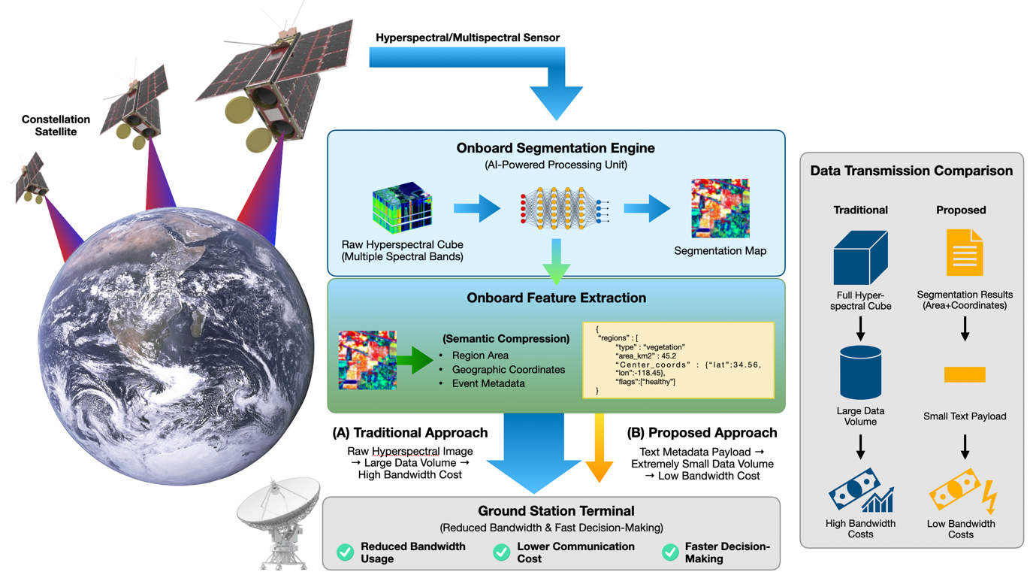
Fig. 1. Source result-centric downlink concept. The refined concept of operations uses the text product as a high-priority alert while retaining raw and ROI products onboard for later retrieval.

The end-to-end workflow is: (1) acquire and calibrate the cube; (2) associate time and geometry; (3) execute segmentation; (4) extract connected ROIs and attributes; (5) apply confidence, quality, and safety gates; (6) generate P3 and store references to P0/P1; (7) insert products into a contact-aware priority queue; (8) transmit P3 at the next feasible contact; and (9) trigger ground alerting, follow-up tasking, or evidence retrieval. This two-tier workflow limits the consequence of an erroneous model output because the underlying measurement remains available.
A practical packet should also include an integrity check, schema version, model hash, processing timestamp, spacecraft and sensor identifiers, and explicit units. Geographic coordinates should not be generated from segmentation alone; they require a validated geolocation chain and associated uncertainty. These fields are minor in volume but central to operational trust, cross-satellite fusion, and post-event audit
Sub-subsection headings are in italics and placed flush on the left-hand margin of the column.

3. Mamba-OpticSatNet Architecture
Mamba-OpticSatNet serves as the onboard segmentation subsystem of the proposed result-centric downlink architecture. The Full and Lite configurations represent two distinct mission operating points. Mamba-OpticSatNet(Full) prioritizes segmentation fidelity through complementary global-modeling branches, whereas Mamba-OpticSatNet(Lite) prioritizes embedded execution efficiency by reducing the number of tokens processed by its global modules. Both configurations first encode cross-band information and local spatial patterns, then perform global token mixing and produce pixel-wise segmentation logits.

3.1. Mamba-OpticSatNet(Full) Architecture
Mamba-OpticSatNet(Full) combines a convolutional neural network (CNN) stem with two parallel global-modeling branches, as illustrated in Fig. 2. The CNN stem extracts cross-band feature combinations and local spatial patterns from the hyperspectral input. The Transformer branch then provides direct interactions among spatial tokens, whereas the selective state-space model (SSM) branch performs long-range mixing along the flattened token sequence. These two branches provide complementary representations: self-attention supports direct global token interaction but includes a token-interaction term that grows quadratically with sequence length, while selective SSM processing scales approximately linearly with sequence length for a fixed model width and state size [24], [25].

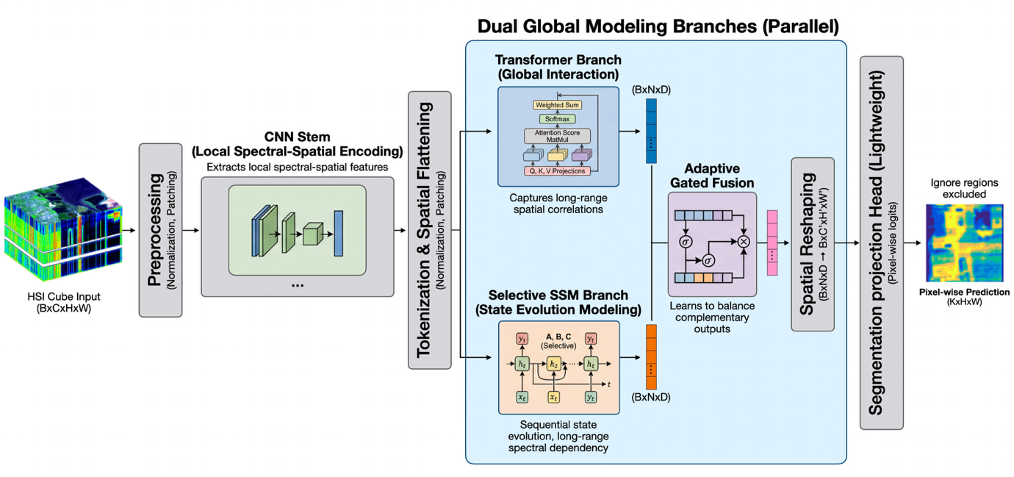
Fig. 2. Schematic architecture of Mamba-OpticSatNet(Full), consisting of a CNN stem, parallel Transformer and selective SSM branches, adaptive gate fusion, spatial restoration, and a lightweight segmentation head.

Section 2 represents a single hyperspectral acquisition as $Χ ∈ R^{H × W × B}$, where B denotes the number of spectral bands. For network implementation, a minibatch is written in channel-first format as $Χ ∈ R^{N_{b} × B × H × W}$, where $N_{b}$ is the minibatch size. The CNN stem and tokenization operation are defined as

$F=f_{CNN}\left(X\right)∈ R^{N_{b} × B × H × W}, T=∅\left(F\right)∈R^{N_{b} × N_{F} × D}, N_{F}=H_{f}W_{f}$ (20)

where $C_{f}$ is the number of CNN feature channels, and $H_{f}$ and $W_{f}$ are the spatial dimensions of the CNN feature map, D is the token embedding dimension, and $∅\left(∙\right)$ denotes spatial flattening followed by embedding projection. Importantly, the token count is determined by the feature-map dimensions $H_{f}W_{f}$, rather than necessarily by the original input dimensions HW.

The Transformer and selective SSM branches independently process the same token sequence:

$Z_{Tr}=f_{Tr}\left(T\right), Z_{SSM}=f_{SSM}\left(T\right), Z_{Tr}, Z_{SSM}∈ R^{N_{b} × N_{F} × D}$(21)

Here, $f_{Tr}\left(∙\right)$ denotes the Transformer branch and $f_{SSM}(∙)$ denotes the selective SSM branch. The Transformer branch models direct interactions among all tokens, while the selective SSM branch models long-range dependencies along the ordered token sequence.

The two branch outputs are combined through an adaptive gated-fusion operation:

$G=σ​\left(W_{g}(\left[Z_{Tr}∥Z_{SSM}\right])\right), G∈R^{N_{b} × N_{F} × D}$ (22)

Where $∥$ denotes concatenation along the embedding dimension, $σ(∙)$ is the sigmoid function, and $f_{g} : R^{2D}⟶ R^{D}$ is a learnable gating function applied to each token. The source formulation represents $f_{g}$ as a multilayer perceptron. If the final implementation instead uses a single linear projection, $f_{g}$ should be explicitly defined as $f_{g}(U) = UW_{g}+b_{g}$.
The fused token representation is

$Z=G⊙Z_{Tr}+\left(1-G\right)⊙Z_{SSM}$ (23)

where $⊙$ denotes channel-wise multiplication. Because G has the same token and embedding dimensions as the branch outputs, Eq. (23) represents token-wise and feature-wise adaptive fusion. This differs from using a fixed addition or retaining the concatenated representation as the final fused feature.
The fused token sequence is first restored to a spatial feature map, $​ρ(Z) ∈ R^{N_{b} × D × H_{f} × W_{f}}$, and is then processed by the segmentation head:

$L=f_{seg}(ρ(Z))∈ R^{N_{b} × D × H × W}, {\hat{Y}}_{n,h,w}=arg max_{k∈\{0,…,K-1\}}L_{n,k,h,w}$ (24)

where L denotes the per-class pixel logits, K is the number of segmentation classes, and $\hat{Y}$ is the final discrete segmentation map. The function $f_{seg}(∙)$ includes any spatial upsampling required to restore the output to the original H×W resolution.
Mamba-OpticSatNet(Full) is therefore evaluated as the accuracy-oriented configuration. Its measured advantage is associated with the complete architecture; the individual contributions of the CNN stem, Transformer branch, selective SSM branch, and adaptive gate cannot be established without controlled component-ablation experiments.

3.2. Mamba-OpticSatNet(Lite) Architecture
Mamba-OpticSatNet(Lite) is the deployment-oriented configuration shown in Fig. 3. Rather than uniformly reducing every channel dimension of Mamba-OpticSatNet(Full), Lite introduces early spatial downsampling and compact global-processing modules. The downsampling stem reduces the spatial dimensions of the intermediate feature map before tokenization, thereby decreasing the sequence length processed by the Transformer and SSM-inspired modules.
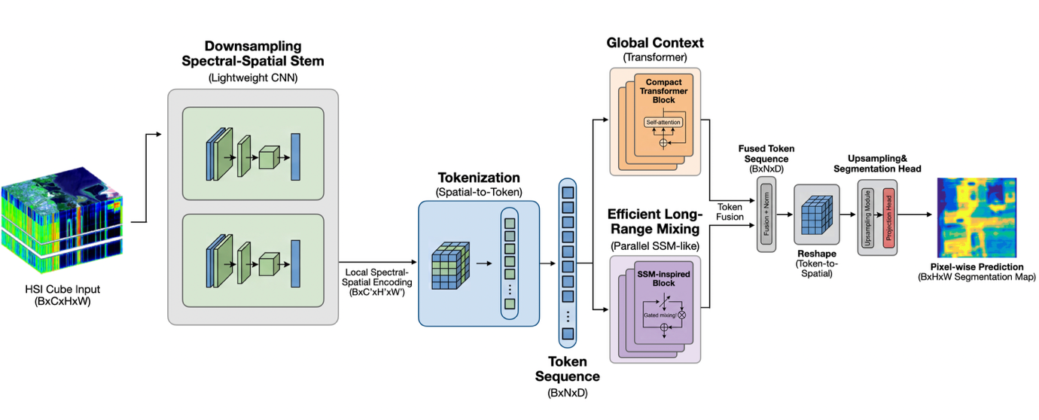
Fig. 3. Schematic architecture of Mamba-OpticSatNet(Lite). Early spatial downsampling shortens the token sequence before compact Transformer and SSM-inspired global mixing, lightweight token fusion, spatial restoration, and pixel-wise prediction.

Let the token-grid dimensions of Full and Lite be $H_{f} × W_{f}$ and $H_{L} × W_{L}$, respectively. If Lite applies a relative downsampling factor s to both spatial dimensions,

$H_{L}≈\frac{H_{F}}{S}, W_{L}≈\frac{W_{F}}{S}, N_{L} = H_{L}W_{L}≈\frac{N_{F}}{S^{2}}$ (25)

The shorter token sequence is processed by a compact Transformer block and an efficient SSM-inspired block. Their outputs are combined using a lightweight token-fusion operation, reshaped to a spatial representation, and upsampled by the segmentation head to recover the original output resolution.
For fixed embedding width, state dimension, block count, and implementation, the per-block sequence-mixing terms scale approximately as

$\begin{matrix}\frac{C_{attn,int,L}}{C_{attn,int,F}} & ≈{\left(\frac{N_{L}}{N_{F}}\right)}^{2}≈\frac{1}{s^{4}}, \\ \frac{C_{SSM,scan,L}}{C_{SSM,scan,F}} & ≈\frac{N_{L}}{N_{F}}≈\frac{1}{s^{2}}.\end{matrix}$ (26)

Where $C_{attn,int}$ denotes the quadratic token-interaction term of self-attention and $C_{SSM,scan}$ denotes the sequence-length-dependent scan term of the SSM-inspired block.
Equation (26) describes only the reduction attributable to token count. It does not represent the total computational complexity of either network. The complete GMAC count also depends on embedding width, the number of blocks, linear projections, convolutional stems, normalization layers, fusion operations, and the segmentation head. Measured latency can additionally be affected by memory traffic, tensor layout, kernel implementation, numerical precision, clock configuration, and accelerator utilization. The efficiency of Lite is therefore evaluated empirically rather than inferred solely from Eq. (26).

3.3. Computational Cost and Onboard Efficiency
For the benchmark input configuration, Mamba-OpticSatNet(Full) requires 0.240 giga multiply–accumulate operations (GMACs) and contains 0.681 million trainable parameters. Mamba-OpticSatNet(Lite) requires 0.066 GMACs and contains 0.288 million trainable parameters. The relative reductions from Full to Lite are

$Δ_{MAC}=1-\frac{0.066}{0.240}=0.725 \left(72.5\%\right)$ (27)

$Δ_{param}=1-\frac{0.288}{0.681}=0.577 \left(57.7\%\right)$ (28)

These values characterize arithmetic workload and parameter count for the benchmark model input. They should not be interpreted as cube-level latency or complete onboard-system resource consumption.
For a model with $N_{θ}$ parameters stored using $b_{θ}$ bits per parameter, the parameter-tensor storage requirement is

$S_{θ}=\frac{N_{θ}b_{θ}}{8} bytes.$ (29)

At 32-bit floating-point precision, Eq. (29) gives $S_{θ,Full} = 0.681 × {10}^{6} × 4 = 2.724MB$, and $S_{θ,Lite} = 0.288 × {10}^{6} × 4 = 1.152MB$, where decimal megabytes are used. These values correspond to approximately 2.598 MiB and 1.099 MiB, respectively, when binary mebibytes are used.
A 16-bit representation would nominally halve parameter-tensor storage, but its use would require separate validation of segmentation accuracy, numerical stability, and accelerator compatibility.
GMAC count and parameter count are architecture-level indicators and are not sufficient predictors of measured onboard throughput or energy consumption. Transformer attention, selective scans, memory access, preprocessing, host-to-device transfer, dynamic allocation, power mode, and thermal conditions can materially affect latency. Accordingly, Section 5 reports workstation-level patch latency separately from embedded cube-level latency because the two measurements correspond to different workloads and execution environments.

4. Experimental Setup
4.1 Dataset, Preprocessing and Training setup
Experiments were conducted using OHID-1, a hyperspectral Earth-observation dataset comprising 32 spectral bands with a spatial resolution of 10 m [26]. The public OHID-1 dataset provides seven native land-cover categories: Building, Farmland, Forest, Road, Water, Bare Land, and Fish Shed. In contrast, the present segmentation experiment uses a four-class derivative benchmark consisting of C0 Vegetation, C1 Cropland, C2 Urban, and C3 Water. Pixels not included in the four evaluated classes are assigned the ignore value 255 and excluded from both training-loss computation and performance evaluation.
The input hyperspectral image was loaded in band–height–width order and standardized independently for each spectral band:
${\tilde{X}}_{b}\left(x,y\right)=\frac{X_{b}\left(x,y\right)-μ_{b}}{σ_{b}+ε}$ (30)

where the $X_{b}\left(x,y\right)$ is the adiometric value at spatial location (x,y) in band b, $μ_{b}$ and $σ_{b}$ are the mean and standard deviation used for that band, and $ε > 0$ is small constant introduced to prevent division by zero.
The scene was partitioned into non-overlapping 32×32 patches using a stride of 32. Patches containing only ignore-index pixels were removed. The remaining patches were randomly shuffled and divided into an 80% training subset and a 20% held-out evaluation subset.
Because the training and evaluation patches were sampled from the same hyperspectral scene, the adopted protocol constitutes a within-scene random split. Spatially adjacent or spectrally similar regions from the same scene may therefore occur in both subsets. Consequently, the reported results characterize within-scene predictive performance and should not be interpreted as evidence of cross-scene, cross-location, cross-season, or cross-sensor generalization.

4.2 Evaluation Metrics and Baseline Models
For each evaluated class $k ∈ \{0,...,K-1\}$ let $TP_{k}$, $FP_{k}$, and $FN_{k}$ denote the true-positive, false-positive, and false-negative pixel counts, respectively. Pixels assigned the ignore value 255 are excluded from all metric calculations. The intersection over union for class k is defined as

${IoU}_{k}=\frac{TP_{k}}{TP_{k}+FP_{k}+FN_{k}}$ (31)

For K evaluated classes, the mean intersection over union is

$mIoU=\frac{1}{K}\sum_{k=1}^{K}{{IoU}_{k}}$ (32)

Overall accuracy and average class accuracy are defined as

$OA=\frac{\sum_{k=1}^{K}{T}P_{k}}{N_{valid}}$ (33)

$AA=\frac{1}{K}\sum_{k=1}^{K}{\frac{TP_{k}}{TP_{k}+FN_{k}}}$ (34)

IoU and mIoU measure class-wise spatial overlap, OA measures the fraction of all valid pixels classified correctly, and AA assigns equal weight to the recall of each class. In the present four-class benchmark, K=4, with C0 corresponding to Vegetation, C1 to Cropland, C2 to Urban, and C3 to Water.
The comparison includes FCN-32s as a canonical fully convolutional segmentation baseline [27]; U-Net and UNet++ as encoder–decoder architectures with skip connections [28], [29]; HybridSN as a hyperspectral spectral–spatial architecture combining three-dimensional and two-dimensional convolutions [30]; SpectralFormer and ViT as Transformer-based baselines [31], [32]; RS-Mamba as a state-space-based remote-sensing dense-prediction model [33]; and RESSU as a hyperspectral semantic-segmentation network [34]. HybridSN and SpectralFormer were originally proposed primarily for hyperspectral image classification, while ViT was proposed for image classification. These models were adapted to pixel-wise segmentation for the present benchmark. The final manuscript should describe the output-head replacement, spatial reshaping, upsampling method, and supervision procedure applied to each adapted baseline to ensure reproducibility and comparability.

4.3 Embedded Hardware and STK Configuration
Training and patch-level benchmarking were performed on the workstation summarized in Table 2. All compared models were evaluated under the same hardware and software environment. The reported workstation inference time represents latency per 32×32 patch and is used only for relative comparison within the segmentation benchmark.

Table 2. Workstation configuration used for model training and patch-level evaluation.
Category | Specification
Operating system | Linux 6.8.0-90-generic (x86_64, glibc 2.35)
Python | 3.10.19 (Conda-forge, GCC 14.3.0)
CPU | x86_64, 8 physical cores / 16 threads
System memory | 30.51 GB
GPU | NVIDIA GeForce RTX 5090
GPU memory | 31.36 GB
NVIDIA driver | 570.195.03
CUDA / cuDNN | 12.8 / 91701
PyTorch | 2.11.0. dev20260207+cu128

Embedded evaluation was conducted using Mamba-OpticSatNet(Lite) on NVIDIA Jetson Xavier NX, Jetson AGX Xavier, Jetson Orin NX, and Jetson AGX Orin platforms. Cube-level latency, reported average power, estimated energy per inference, and throughput are presented in Section 5.5.
The workstation patch latency and embedded cube-level latency represent different workloads and should not be directly compared. The former measures a single 32×32 patch on an RTX 5090, whereas the latter represents processing of the evaluated cube-level workload on an embedded platform.
The constellation and ground-contact screening scenario was implemented using Ansys Systems Tool Kit (STK). Table 3 summarizes both the orbital configuration and aggregate access-duration statistics.

Table 3. STK constellation configuration and aggregate ground-contact results.
Parameter | Value
Orbit altitude | 450 km
Inclination | 76 deg
Number of orbital planes | 5
Satellites per plane | 4
Total satellites | 20
Ground station | Virtual Station is located at KAIST
Mean access duration | 302 s
Minimum access duration | 4.6 s
Maximum access duration | 420 s
Access-duration standard deviation | 90.4 s

The available STK outputs represent geometric access durations. The analysis does not yet include a complete communication link budget, elevation-dependent data rate, antenna gain and pointing constraints, Doppler effects, modulation and coding, packet retransmission, or chronological competition among the 20 satellites. The STK results are therefore interpreted as a contact-availability screening scenario rather than as a fully validated communication-system model.

5. Results and Mission-Level Analysis
The results are interpreted across three connected layers: segmentation performance, embedded execution, and communication demand. Measured quantities are distinguished from scenario assumptions so that reductions in transmitted volume are not conflated with unverified reductions in absolute end-to-end mission latency.

5.1 Quantitative Segmentation Results
Table 4 summarizes the segmentation accuracy and patch-level computational characteristics of Mamba-OpticSatNet and the baseline models on the four-class OHID-1 derivative benchmark.
Mamba-OpticSatNet(Full) achieved the highest reported mIoU, OA, and AA among the evaluated models, with values of 0.908, 0.981, and 0.949, respectively. Its largest class-wise advantage occurred for C2 Urban, for which it achieved an IoU of 0.748. The next-highest C2 result was obtained by HybridSN with an IoU of 0.701.
The stronger C2 Urban performance is consistent with the design objective of combining local spectral–spatial encoding with global interaction and long-range dependency modeling. Urban regions contain spectrally mixed surfaces, fine boundaries, road-like structures, and spatially distributed built-up patterns that can be difficult to distinguish using local features alone. Nevertheless, because controlled component-ablation experiments were not conducted, the C2 improvement cannot be attributed causally to the Transformer branch, selective SSM branch, or adaptive gated-fusion mechanism individually.
Mamba-OpticSatNet(Lite) achieved an mIoU of 0.877, an OA of 0.979, and an AA of 0.928. Its class-wise IoUs were 0.974 for C0 Vegetation, 0.949 for C1 Cropland, 0.630 for C2 Urban, and 0.953 for C3 Water. Lite therefore maintained competitive overall segmentation performance while substantially reducing arithmetic complexity and parameter count.
Because the benchmark uses a single within-scene random split and no repeated-run statistics are currently reported, numerical differences of only a few thousandths should not be interpreted as statistically resolved. The principal finding is therefore the overall accuracy–resource trade-off between Full and Lite rather than a universal ranking across datasets or geographic regions.

Table 4. Reported segmentation accuracy and patch-level efficiency on the four-class OHID-1 derivative benchmark (C0=vegetation, C1=Cropland, C2=Urban, C3=Water).
 | FCN-32s  (Long et al., 2015) | U-Net  (Roneberger et al., 2015) | UNet++  (Zhou et al., 2018) | HybridSN  (Roy et al., 2019) | SpectralFormer  (Hong et al., 2021) | ViT  (Dosovitskiy et al., 2021) | RS-Mamba  (Zhao et al., 2024) | RESSU  (Wu et al., 2024) | Mamba-OpticSatNet(Lite)  (Ours) | Mamba-OpticSatNet(Full)  (Ours)
mIoU | 0.776 | 0.887 | 0.886 | 0.896 | 0.593 | 0.715 | 0.85 | 0.86 | 0.877 | 0.908
OA | 0.955 | 0.98 | 0.979 | 0.98 | 0.877 | 0.939 | 0.968 | 0.978 | 0.979 | 0.981
AA | 0.838 | 0.926 | 0.924 | 0.944 | 0.681 | 0.789 | 0.897 | 0.916 | 0.928 | 0.949
C0 IoU | 0.941 | 0.974 | 0.972 | 0.973 | 0.855 | 0.937 | 0.959 | 0.972 | 0.974 | 0.977
C1 IoU | 0.894 | 0.951 | 0.953 | 0.945 | 0.724 | 0.826 | 0.911 | 0.958 | 0.949 | 0.946
C2 IoU | 0.368 | 0.669 | 0.669 | 0.701 | 0.104 | 0.227 | 0.586 | 0.603 | 0.63 | 0.748
C3 IoU | 0.9 | 0.954 | 0.95 | 0.966 | 0.691 | 0.872 | 0.945 | 0.95 | 0.953 | 0.963
Inference (ms) | 0.59 | 0.675 | 1.978 | 0.798 | 0.44 | 3.712 | 0.412 | 0.479 | 0.384 | 6.016
MACs (G) | 0.397 | 0.667 | 1.284 | 3.378 | 0.069 | 0.421 | 0.189 | 0.279 | 0.066 | 0.240
Params (M) | 14.798 | 7.714 | 8.943 | 2.675 | 0.958 | 90.813 | 0.383 | 5.03 | 0.288 | 0.681

5.2 Accuracy and Efficiency Comparison
Figure 4 visualizes the relationship between segmentation accuracy and architecture-level resource requirements. The left panel compares mIoU with GMACs, while the right panel compares parameter count with mIoU.
Mamba-OpticSatNet(Lite) represents a resource-efficient operating point in the benchmark, requiring 0.066 GMACs and 0.288 million parameters while achieving an mIoU of 0.877. SpectralFormer requires a similar arithmetic workload of 0.069 GMACs but achieves a substantially lower mIoU of 0.593.
Mamba-OpticSatNet(Full) requires 0.240 GMACs and contains 0.681 million parameters, while achieving the highest reported mIoU of 0.908. Its workstation patch latency of 6.016 ms is longer than those of several models with greater GMAC counts. This mismatch demonstrates that arithmetic operation count alone does not determine wall-clock latency. Kernel implementation, memory traffic, operation type, tensor layout, and accelerator utilization also affect runtime.
HybridSN achieves an mIoU of 0.896 but requires 3.378 GMACs. ViT contains 90.813 million parameters while achieving an mIoU of 0.715. These results support model selection using an accuracy–resource Pareto perspective rather than accuracy or model size alone.
For the proposed alert-first mission concept, Mamba-OpticSatNet(Lite) is the more appropriate embedded candidate because cube-level execution time and energy on the target onboard processor, rather than workstation patch latency alone, determine mission feasibility.

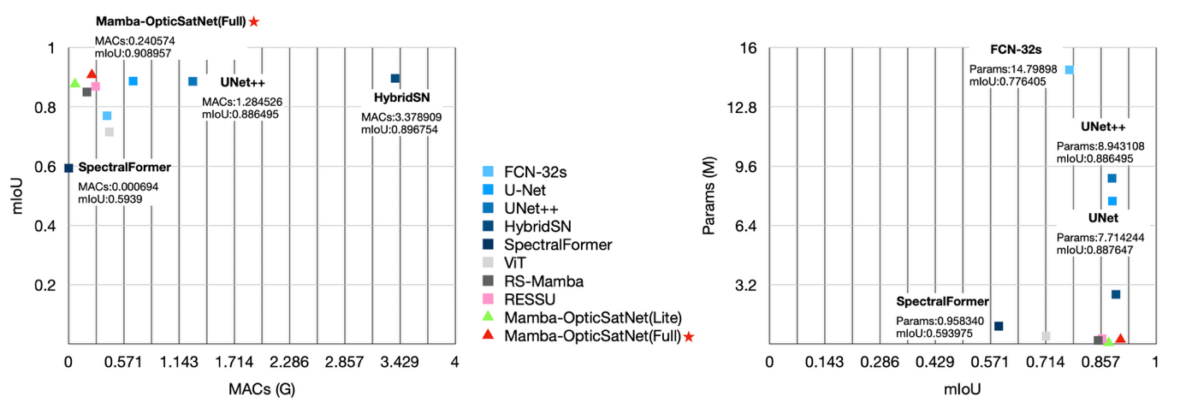
Fig. 4. Accuracy–efficiency comparison on the four-class OHID-1 derivative benchmark. Left: mIoU versus GMACs. Right: parameter count versus mIoU. Mamba-OpticSatNet(Full) achieves the highest reported mIoU, whereas Mamba-OpticSatNet(Lite) provides a lower-complexity operating point with competitive segmentation performance.

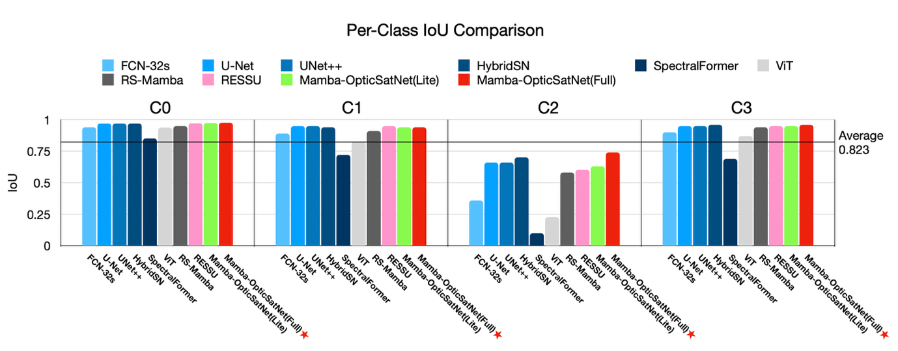
Fig. 5. Per-class IoU comparison on the four-class OHID-1 derivative benchmark (C0 = Vegetation, C1 = Cropland, C2 = Urban, and C3 = Water). The largest performance differences occur for C2 Urban, for which Mamba-OpticSatNet(Full) achieves the highest reported IoU.

5.3 Qualitative Segmentation Results
Figure 6 presents a qualitative comparison of the predicted segmentation maps for C0 Vegetation, C1 Cropland, C2 Urban, and C3 Water.
The qualitative panel is broadly consistent with the quantitative observation that the largest differences among the models occur for C2 Urban. Mamba-OpticSatNet(Full) preserves more fine-scale urban and road-like structures and produces fewer broad class substitutions than several weaker Transformer-based baselines. Mamba-OpticSatNet(Lite) retains the dominant scene structure but omits some small or spectrally mixed urban regions, which is consistent with its lower C2 IoU compared with Full.
U-Net, UNet++, HybridSN, RS-Mamba, and RESSU produce broadly plausible segmentation maps, consistent with their clustered mIoU values. However, the qualitative panel should not be used to establish statistical superiority because it represents only a selected scene or spatial extent.
For full reproducibility, the final manuscript should report the exact scene identifier, the spectral bands used to generate the pseudo-RGB image, the four-class remapping procedure, the color-map definition, and the spatial extent shown in Fig. 6.

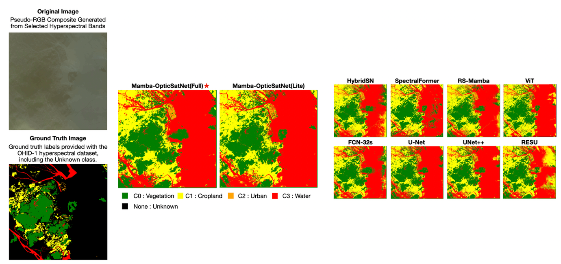
Fig. 6. Qualitative segmentation comparison on the four-class OHID-1 derivative benchmark. The displayed classes are C0 Vegetation, C1 Cropland, C2 Urban, and C3 Water; pixels assigned the ignore value 255 are displayed as Unknown.

5.4 Mamba-OpticSatNet (Full) - (Lite) Architecture Trade
The comparison between Mamba-OpticSatNet(Full) and Mamba-OpticSatNet(Lite) evaluates two complete architecture configurations rather than a controlled component ablation. Consequently, it quantifies the practical operating trade between the two configurations but does not establish the independent contribution of the CNN stem, Transformer branch, selective SSM branch, adaptive gate, or early downsampling.
A controlled ablation study would require removing or replacing one component at a time while maintaining comparable training conditions and parameter budgets. Repeated training runs and confidence intervals would also be required to separate architecture-related effects from optimization variance.

Table 5. Reported operating trade between Mamba-OpticSatNet(Full) and Mamba-OpticSatNet(Lite)
Quantity | Full | Lite | Lite relative to Full
mIoU | 0.908 | 0.877 | -0.031 absolute
C2 IoU | 0.748 | 0.630 | -0.118 absolute
MACs(G) | 0.240 | 0.066 | 72.5% reduction
Parameters(M) | 0.681 | 0.288 | 57.7% reduction
Patch latency(ms) | 6.016 | 0.384 | 15.7x faster

The Full-to-Lite comparison shows that Lite incurs an absolute decrease of 0.031 in mIoU and 0.118 in C2 Urban IoU while reducing GMACs by 72.5%, parameter count by 57.7%, and workstation patch latency by a factor of approximately 15.7. Whether this trade is acceptable depends on the operational consequence of missed or under-segmented urban regions in the target mission

5.5 Embedded Inference Performance
Energy per inference is evaluated from mean power and measured processing time as

$E_{inf,est} = {\overline{P̄}}_{inf} T_{inf}$ (35)

where ${\overline{P̄}}_{inf}$ is the reported average power during inference and $T_{inf}$ is the cube-level inference time in seconds.
Jetson AGX Orin achieved the shortest reported cube-level latency of 1.6976 s and the lowest estimated energy per inference of 42.44 J. Although its reported average power is higher than those of the NX platforms, its substantially shorter execution time results in lower total energy per evaluated inference.
This behavior is consistent with a race-to-idle interpretation, in which a higher-power processor may consume less total energy by completing the workload more rapidly. Confirming a complete race-to-idle benefit would nevertheless require time-resolved active and idle power measurements.

Table 6. Reported cube-level embedded performance of Mamba-OpticSatNet(Lite)
Platform | Latency (ms) | Power (W) | Energy / inference (J) | Throughput (cube/s)
Jetson Xavier NX | 8826.2 | 12.50 | 110.36 | 0.11
Jetson AGX Xavier | 4753.7 | 28.50 | 135.51 | 0.21
Jetson Orin NX | 6620.0 | 15.00 | 99.30 | 0.15
Jetson AGX Orin | 1697.6 | 25.00 | 42.44 | 0.59

For the assumed 100 kB semantic-alert product, the corresponding communication payload is $B_{3}= 0.80 Mbit$. At an effective application-layer throughput of 1 Mbit/s, the ideal processing-plus-airtime requirement is

$T_{alert,ideal} = T_{proc} + \frac{D_{3}}{R_{eff}} = 1.6976 + 0.80 = 2.4976 s$(36)

Relative to the minimum geometric access duration of 4.6 s, Eq. (36) leaves an idealized margin of approximately 2.10 s. This value is not an end-to-end latency guarantee because it excludes acquisition finalization, calibration, geolocation, ROI extraction, packet generation, radio acquisition, acknowledgements, scheduling, retransmission, and ground processing.

5.6 STK-Based Communication Analysis
At the illustrative constant application-layer throughput of 1 Mbit/s, the minimum, mean, and maximum contact capacities are

$V_{min} = 4.6 Mbit = 575 kB, V_{mean} = 302 Mbit = 37.75 MB, V_{max} = 420 Mbit = 52.5 MB$(37)

A 100 kB semantic alert fits within even the reported minimum geometric access duration under the assumed constant-throughput model. In contrast, a 1 MB product requires 8 s of ideal continuous airtime and therefore does not fit within a 4.6 s minimum access, although it fits within the representative mean access duration.
These values describe idealized geometric-access capacity. Flight-level analysis would additionally require an elevation-dependent link budget, antenna and pointing models, Doppler effects, modulation and coding, radio acquisition time, packet loss, and protocol efficiency.

5.7 Downlink Reduction and Mission Latency Analysis

Table 7. Comparison of raw-cube and initial semantic-alert downlink requirements.
Quantity | Traditional P0 downlink | Result-centric P3 downlink
Payload size | 1.64 GB = 13,120 Mbit | 100 kB = 0.80 Mbit
Continuous transmission time at 1 Mbit/s | 13,120 s (3.64 h) | 0.80 s
Mean-duration contacts required | 44 | 1
Fits 4.6 s minimum access? | No | Yes
Semantic reduction factor | 1 | 16,400:1
Volume reduction | 0% | 99.9939%

The raw and semantic payloads are converted to communication units as

$B_{0}= {8D}_{0} = 8(1.64×10⁹) = 13,120 Mbit, B_{3}=D_{3} = 8(100×{10}^{3}) = 0.80 Mbit$(38)

At an effective rate of 1 Mbit/s, their ideal continuous transmission times are

$T_{air,0} = \frac{13,120 Mbit}{1 Mbit/s} = 13,120 s = 3.64 h, T_{air,3} = \frac{0.80 Mbit}{1 Mbit/s} = 0.80 s$(39)

Using the 302 s mean access duration, the representative contact demands are

${\overline{N}}_{cont}(0) = \left\lceil \frac{13,120}{302}\right\rceil = 44, {\overline{N}}_{cont}(3) = \left\lceil \frac{0.80}{302}\right\rceil = 1$(40)

The semantic reduction factor and percentage reduction in initial alert-downlink volume are

$F_{sem} = \frac{D_{0}}{D_{3}} = 16,400:1, η_{red} = (1 - \frac{D_{3}}{D_{0}})×100\% = 99.9939\%$(41)

Even a 1 MB semantic product fits within one mean contact and reduces transmitted volume by 99.939%. The minimum-contact condition is more restrictive: at 1 Mbit/s, the ideal payload ceiling during a 4.6 s access is

$B_{max,min} = R_{eff} T_{min} = 4.6 Mbit, D_{max,min} = \frac{B_{max,min}}{8} = 575 kB$(42)

A bounded semantic-message schema or fragmentation policy is therefore required when P3 contains many ROIs, detailed polygon boundaries, uncertainty arrays, or image thumbnails.
Result-centric downlink reduces the initial transmitted volume, queue occupancy, ideal airtime, and representative contact demand. However, without chronological access intervals and communication scheduling, neither absolute delivery latency nor a numerical end-to-end speedup can be established.

Table 11. Sensitivity of communication demand to the assumed semantic-alert size.
P3 size | Payload | Tx time at 1 Mbit/s | Mean contacts | Reduction factor | Volume reduction | Fits 4.6 s?
10 kB | 0.08 Mbit | 0.08 s | 1 | 164,000:1 | 99.99939% | Yes
100 kB | 0.80 Mbit | 0.80 s | 1 | 16,400:1 | 99.99390% | Yes
1 MB | 8.00 Mbit | 8.00 s | 1 | 1,640:1 | 99.93902% | No

6. Conclusion
This study reframes onboard hyperspectral segmentation as a component of a result-centric mission architecture. The proposed architecture establishes a fast semantic-alert path while retaining raw and ROI products onboard for subsequent evidence retrieval. The segmentation benchmark uses four derivative classes: C0 Vegetation, C1 Cropland, C2 Urban, and C3 Water.
Mamba-OpticSatNet(Full) achieved the highest reported mIoU of 0.908 among the evaluated models, with its largest class-wise advantage occurring for C2 Urban. Mamba-OpticSatNet(Lite) achieved an mIoU of 0.877 while reducing model complexity to 0.288 million parameters and 0.066 GMACs. On Jetson AGX Orin, Lite completed the evaluated cube-level workload in 1.698 s with an estimated energy requirement of 42.44 J per inference.
Under the illustrative STK scenario and an assumed application-layer throughput of 1 Mbit/s, changing the initial downlink product from a 1.64 GB hyperspectral cube to a 100 kB semantic alert reduces transmitted volume by 99.9939% and representative mean-duration contact demand from 44 contacts to one. These results support an alert-first, evidence-later concept of operations. They do not, however, demonstrate an absolute 44-fold reduction in end-to-end mission latency because actual latency remains dependent on contact chronology, scheduling, protocol overhead, retransmissions, and link-budget conditions.
Future work should include explicit documentation of the native-to-derived OHID-1 class mapping, scene-separated validation, repeated training runs, component ablations, probability calibration, empirical semantic-message size distributions, high-fidelity link analysis, hardware-in-the-loop timing, fault injection, and on-orbit validation of the dual-path $P_{3}/P_{0}$ policy. Constellation-level studies should additionally model competition among multiple satellites for shared ground resources and quantify the effects of semantic products on data backlog, scheduling fairness, and event-response probability.

References
[1] K. Woellert, P. Ehrenfreund, A. J. Ricco, and H. Hertzfeld, “Cubesats: Cost-effective science and technology platforms for emerging and developing nations,” Advances in Space Research, vol. 47, no. 4, pp. 663–684, Feb. 2011, doi: 10.1016/j.asr.2010.10.009.
[2] “Come Circular Orbit”.
[3] G. Petelin, M. Antoniou, and G. Papa, “Multi-objective approaches to ground station scheduling for optimization of communication with satellites,” Optimization and Engineering, vol. 24, no. 1, pp. 147–184, Mar. 2023, doi: 10.1007/s11081-021-09617-z.
[4] B. Denby and B. Lucia, “Orbital edge computing: Nanosatellite constellations as a new class of computer system,” in International Conference on Architectural Support for Programming Languages and Operating Systems - ASPLOS, Association for Computing Machinery, Mar. 2020, pp. 939–954. doi: 10.1145/3373376.3378473.
[5] Z. Cheng and B. Lucia, “Nanosatellite Constellation and Ground Station Co-design for Low-Latency Critical Event Detection,” Mar. 2025, [Online]. Available: http://arxiv.org/abs/2503.01756
[6] R. Castano et al., “Onboard Classifiers for Science Event Detection on a Remote Sensing Spacecraft,” 2006.
[7] G. Giuffrida et al., “The Φ-Sat-1 Mission: The First On-Board Deep Neural Network Demonstrator for Satellite Earth Observation,” IEEE Transactions on Geoscience and Remote Sensing, vol. 60, 2022, doi: 10.1109/TGRS.2021.3125567.
[8] D. D. Langer et al., “Robust and Reconfigurable On-Board Processing for a Hyperspectral Imaging Small Satellite,” Remote Sens. (Basel)., vol. 15, no. 15, Aug. 2023, doi: 10.3390/rs15153756.
[9] S. Berg, D. D. Langer, C. Chiatante, R. Birkeland, J. A. Justo, and T. A. Johansen, “Post Print 75 th International Astronautical Congress (IAC),” 2024.
[10] N. Ghasemi, J. A. Justo, M. Celesti, L. Despoisse, and J. Nieke, “Onboard Processing of Hyperspectral Imagery: Deep Learning Advancements, Methodologies, Challenges, and Emerging Trends,” IEEE J. Sel. Top. Appl. Earth Obs. Remote Sens., vol. 18, pp. 4780–4790, 2025, doi: 10.1109/JSTARS.2025.3527898.
[11] J. A. Justo et al., “Hyperspectral Image Segmentation for Optimal Satellite Operations: In-Orbit Deployment of 1D-CNN,” Remote Sens. (Basel)., vol. 17, no. 4, Feb. 2025, doi: 10.3390/rs17040642.
[12] A. G. M.-I. G. R. T. I. D. JosephL. G. J. G.-L. Jon Alvarez Justo, “Semantic Segmentation in Satellite Hyperspectral Imagery by Deep Learning,” 2025.
[13] G. Meoni, R. Del Prete, F. Serva, A. De Beusscher, O. Colin, and N. Longepe, “Unlocking the Use of Raw Multispectral Earth Observation Imagery for Onboard Artificial Intelligence,” IEEE J. Sel. Top. Appl. Earth Obs. Remote Sens., vol. 17, pp. 12521–12537, 2024, doi: 10.1109/JSTARS.2024.3418891.
[14] F. Razzano et al., “AI Techniques for Near Real-Time Monitoring of Contaminants in Coastal Waters on Board Future Φsat-2 Mission,” IEEE J. Sel. Top. Appl. Earth Obs. Remote Sens., vol. 17, pp. 16755–16766, 2024, doi: 10.1109/JSTARS.2024.3455992.
[15] R. Giordano and P. Guccione, “ROI-based on-board compression for hyperspectral remote sensing images on GPU,” Sensors (Switzerland), vol. 17, no. 5, May 2017, doi: 10.3390/s17051160.
[16] C. C. Traba, D. Rijlaarsdam, J. Guo, R. Del Prete, and G. Meoni, “Towards onboard thermal hotspots segmentation with raw multispectral satellite imagery,” International Journal of Applied Earth Observation and Geoinformation, vol. 146, Feb. 2026, doi: 10.1016/j.jag.2026.105095.
[17] G. Mateo-Garcia et al., “Towards global flood mapping onboard low cost satellites with machine learning,” Sci. Rep., vol. 11, no. 1, Dec. 2021, doi: 10.1038/s41598-021-86650-z.
[18] M. Ali et al., “Lightweight Cloud Masking Models for On-Board Inference in Hyperspectral Imaging,” Jul. 2025, [Online]. Available: http://arxiv.org/abs/2507.08052
[19] J. Herec, J. Sedmidubsky, and R. Pitoňák, “STTORM-CD low-demand and high-impact disaster monitoring onboard satellites using change detection,” Sci. Rep., vol. 16, no. 1, Dec. 2026, doi: 10.1038/s41598-025-32598-3.
[20] A. D. George and C. M. Wilson, “Onboard Processing with Hybrid and Reconfigurable Computing on Small Satellites,” Proceedings of the IEEE, vol. 106, no. 3, pp. 458–470, Mar. 2018, doi: 10.1109/JPROC.2018.2802438.
[21] F. C. Bruhn, N. Tsog, F. Kunkel, O. Flordal, and I. Troxel, “Enabling radiation tolerant heterogeneous GPU-based onboard data processing in space,” CEAS Space Journal, vol. 12, no. 4, pp. 551–564, Dec. 2020, doi: 10.1007/s12567-020-00321-9.
[22] “Single Event Effect Evaluation of the Jetson AGX Xavier Module Using Proton Irradiation; Single Event Effect Evaluation of the Jetson AGX Xavier Module Using Proton Irradiation,” 2020 IEEE Radiation Effects Data Workshop (in conjunction with 2020 NSREC), 2020, doi: 10.1109/REDW51883.2020.9325840/20/$31.00.
[23] D. Won, K. Hong, D. Lee, H. Lee, and H. Bang, “In-Orbit Validation of a Heterogeneous COTS Architecture for Onboard AI: System-Level Operational Vulnerabilities and Failure Pathways,” International Journal of Aeronautical and Space Sciences, Jul. 2026, doi: 10.1007/s42405-026-01130-w.
[24] A. Gu, K. Goel, and C. Ré, “Efficiently Modeling Long Sequences with Structured State Spaces,” Aug. 2022, [Online]. Available: http://arxiv.org/abs/2111.00396
[25] A. Gu and T. Dao, “Mamba: Linear-Time Sequence Modeling with Selective State Spaces,” May 2024, [Online]. Available: http://arxiv.org/abs/2312.00752
[26] A. Mani et al., “OHID-1: A New Large Hyperspectral Image Dataset for Multi-Classification,” Scientific Data , vol. 12, no. 1, Dec. 2025, doi: 10.1038/s41597-025-04542-7.
[27] J. Long, E. Shelhamer, and T. Darrell, “Fully Convolutional Networks for Semantic Segmentation,” Mar. 2015, [Online]. Available: http://arxiv.org/abs/1411.4038
[28] O. Ronneberger, P. Fischer, and T. Brox, “U-Net: Convolutional Networks for Biomedical Image Segmentation,” May 2015, [Online]. Available: http://arxiv.org/abs/1505.04597
[29] Z. Zhou, M. M. R. Siddiquee, N. Tajbakhsh, and J. Liang, “UNet++: Redesigning Skip Connections to Exploit Multiscale Features in Image Segmentation,” Jan. 2020, [Online]. Available: http://arxiv.org/abs/1912.05074
[30] S. K. Roy, G. Krishna, S. R. Dubey, and B. B. Chaudhuri, “HybridSN: Exploring 3-D-2-D CNN Feature Hierarchy for Hyperspectral Image Classification,” IEEE Geoscience and Remote Sensing Letters, vol. 17, no. 2, pp. 277–281, Feb. 2020, doi: 10.1109/LGRS.2019.2918719.
[31] D. Hong et al., “SpectralFormer: Rethinking Hyperspectral Image Classification with Transformers,” IEEE Transactions on Geoscience and Remote Sensing, vol. 60, 2022, doi: 10.1109/TGRS.2021.3130716.
[32] A. Dosovitskiy et al., “An Image is Worth 16x16 Words: Transformers for Image Recognition at Scale,” Jun. 2021, [Online]. Available: http://arxiv.org/abs/2010.11929
[33] S. Zhao, H. Chen, X. Zhang, P. Xiao, L. Bai, and W. Ouyang, “RS-Mamba for Large Remote Sensing Image Dense Prediction,” Apr. 2024, [Online]. Available: http://arxiv.org/abs/2404.02668
[34] H. Wu, C. Li, and Y. Li, “Full-scale semantic segmentation of hyperspectral imaging based on spatial spatial-spectral joint network,” in ISPRS Annals of the Photogrammetry, Remote Sensing and Spatial Information Sciences, Copernicus Publications, May 2024, pp. 267–274. doi: 10.5194/isprs-annals-X-1-2024-267-2024.

